**Creating Cross-Section Sheets**

You’re at a point where you’ve added your *Sample Lines* to your *Alignment* and your *Corridor* is built.  Now you’re finally at the money maker point of producing Cross-Section Sheets.

Again, there are a few ways of going about this.  I’ll demonstrate one, and afterwards explain why this is my preferred method (for the time being).

From the *Home* Ribbon, in the *Profile and Section Views* select *Create Multiple Views*.

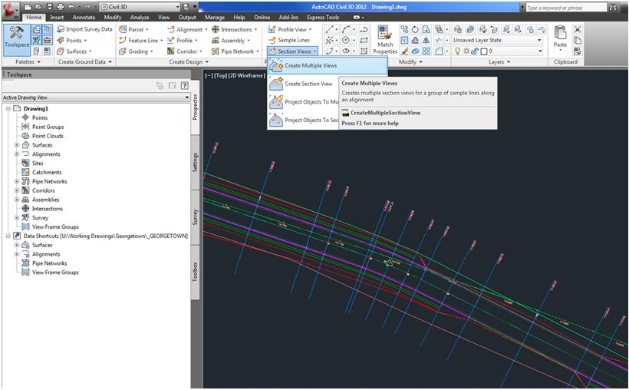

The *Create Multiple Section Views – General*  dialogue box opens.

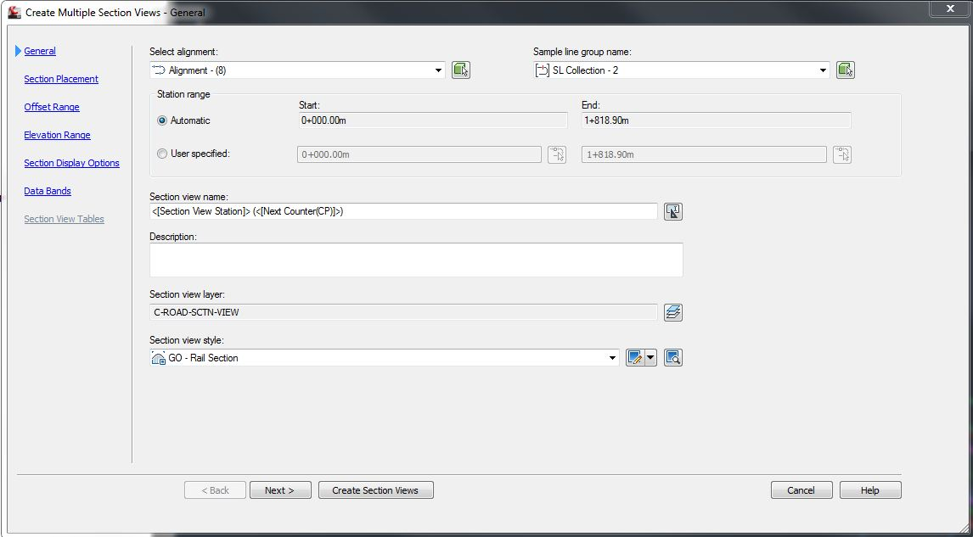

Alternate though the headings on the left. Make sure you have the proper *Alignment* and *Sample Line Group* chosen. You’ll also notice above that I have created a new *Section View Style*.

The second heading – Section Placement is what I want to emphasize. You’ll notice below, on the dialogue box below that I am using *Production* for *Placement Options*.

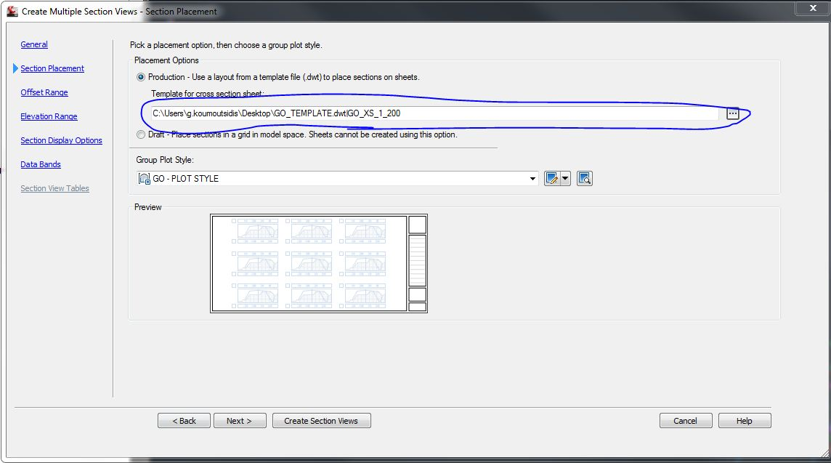

I have chosen a Layout created in a template, that for the time being is saved on my Desktop. The critical point is to create the layout correctly. To do this open your border dwg or dwt file and follow the next step.

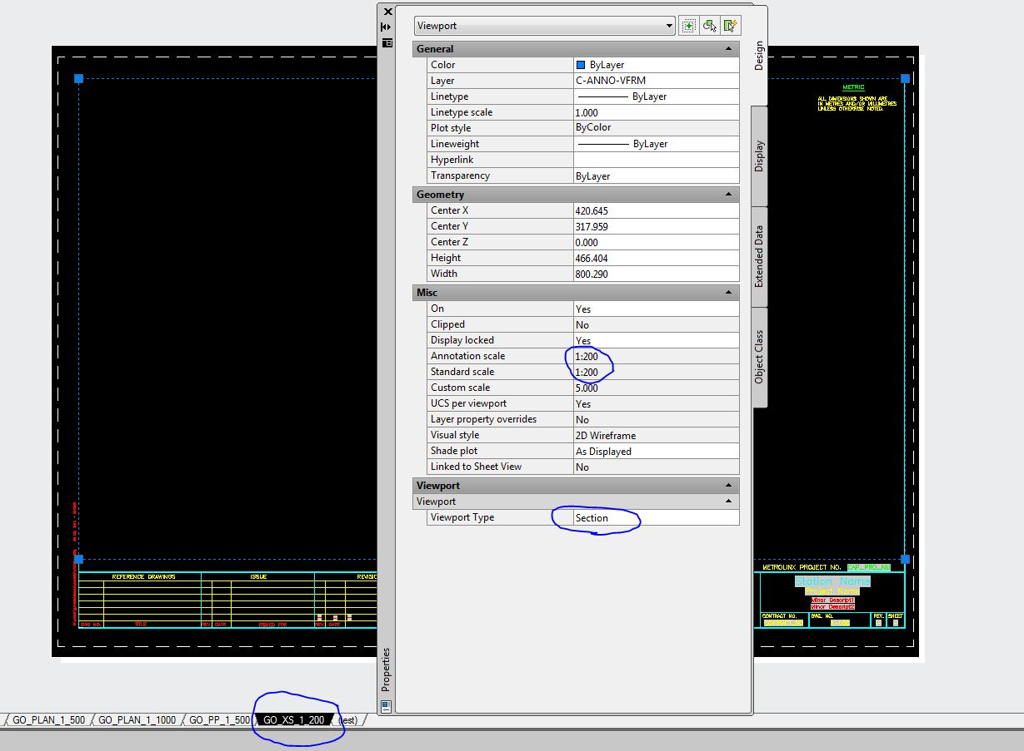

I have circled a few things on the screenshot above (showing the *Properties* of the selected viewport). From the top down:

-Scale for Cross-sections is set to 1:200

Notice Custom Scale is 5 since metric drawings are 1:1000 to begin with.

-Viewport Type – *Section*

This must be selected from the Civil 3D Section View to function. If not, you will probably get an error that mentions something about the layout not having any section views.

-A Layout tab corresponding to a 1:200 scale that can be chosen selected in Image 3.

You’ll notice the screenshot above has multiple tabs. This is the template file. Be sure to save it as “.dwt” file after you make your updates to create the correct size sheet, otherwise it won’t be available for selection (Image 5).

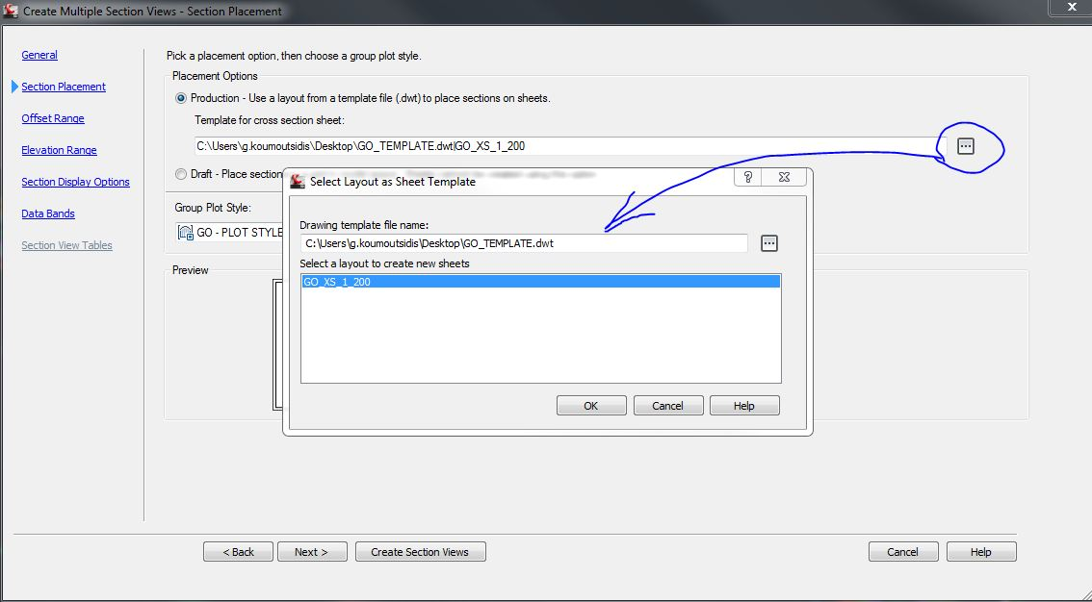

Continue to hit *Next* and modify some of the options as you desire. Alternatively, just select *Create Sections Views* from above.

Once the sections are created, check to see that your page sized correctly.

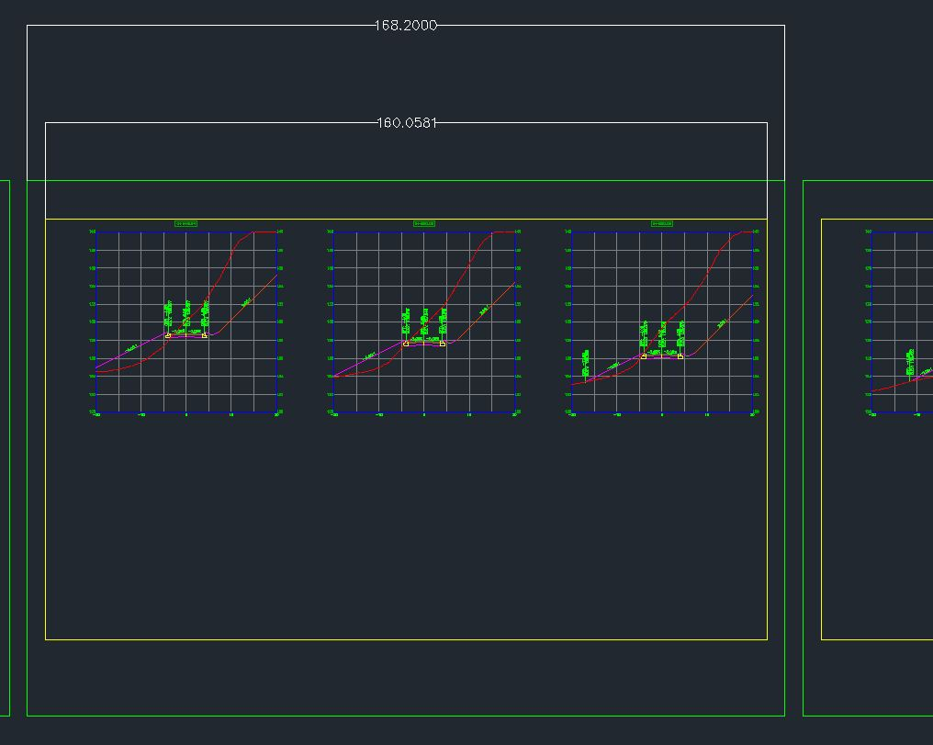

The image above shows the section views created in Model Space. The dimensions show the inside border dimension and the outside page. Compare what was created in Paperspace on the 1:200 Layout.

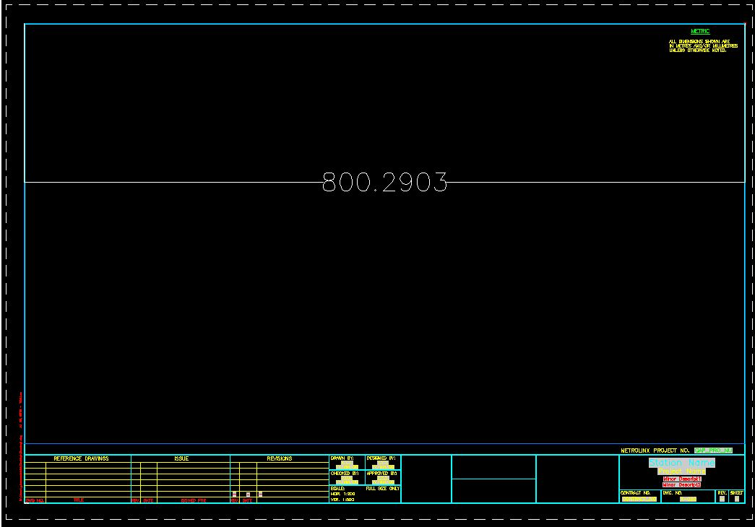

Notice that in Paperspace the inside border measures 800.2903 corresponding to the 160.0581 from Image 6. Remember the 1:200 Standard scale which corresponds to Custom Scale of 5 for a 1:1000 Metric scale as shown on Image 4. (800.2903/160.0581=5)

Now you can begin to create new drawings using your border template and accurately window the cross-section views created by Civil 3D in modelspace.

The process is complete, but I’d be leaving you hanging if I didn’t explain why the preference was made to create the cross-sections in Modelspace and use separate drawings for each individual cross-sections sheet. So my best reasoning for this logic is to access the ability of the *Sheet Set Manager*. You can see from Image 8 below, that the border consists of *Fields* (greyed out).

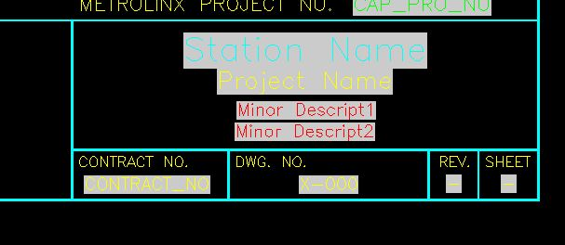

*Fields* are employed for the purpose of using the *Sheet Set Manager*, which allows global changes to the border as well as the ability to make those change (and print/plot) without even opening the drawing (read: Saves mucho tiempo!)

If your unfamiliar with using *Fields* and *Sheet Set Manager,* check this link out:

[*http://www.youtube.com/watch?v=o0Fp0OJ20pg*](http://www.youtube.com/watch?v=o0Fp0OJ20pg)